1.1 Introduction

Neural coding: the aim is to measure and characterize how stimulus attributes (such as light or sound intensity) and motor action (such as movement of an arm) are represented as action potentials.

Neurons propagate signals rapidly over large distances by generating electrical pulses (called action potentials or spikes) that can travel down nerve fibers. Neurons transmit information by firing sequences of spikes in various temporal patterns.

Neurons are highly specialized for generating electrical signals, a neuron contains:
- Dendrites: receive inputs from other neurons. The dendritic tree allows a neuron to receive inputs from many other neurons
- Axon: carries neuronal output to other cells

Cell membrane
The cell membrane is a lipid bilayer of 4 nm thick that is impermeable. It acts as a capacitor by separating the charges inside from the charges outside the cell. Embedded in the cell membrane, we also have ion-conducting channels which lower the effective membrane resistance.

Neurons have physiological specialization with a wide variety of membrane-spanning ion channels that allows ions (sodium, potassium, calcium, chloride, …) to move into and out of the cell. Ion channels control the flow of ions across the cell membrane by opening and closing in response to voltage changes and to both internal and external signals.

The external signal is the difference in electrical potential between:
- Interior of a neuron: the potential inside is about -70mV
- Surrounding extracellular medium: conventionally set to 0 mV

The ions pumps are in the cell membrane and maintain concentration gradients that support the membrane potential difference. During hyperpolarization current in the form of positively charged ions flows out of the cell (or negatively charged ions flow into the cell) thanks to the open channels, thus making the membrane potential more negative. While depolarization is the opposite, that is when current does not flow out of the cell but instead it flows into the cell by changing the membrane potential to less negative (or even positive).

An action potential is generated when a neuron is depolarized sufficiently to raise the membrane potential above a threshold level ⟹ then a positive feedback is initiated and the neuron generates an action potential.
- An action potential is around 100 mV fluctuation (from -70mV to +40mV) in electrical potential across the membrane and it lasts for about 1 ms.
- If an action potential is generated for a few milliseconds it is not possible to start another action potential (aka absolute refractory period) while it is harder to generate an action potential for a longer time (tens of milliseconds after a spike) (aka relative refractory period).
- Action potential is the only form of membrane potential fluctuation that can propagate over a large distance.

The membrane conductance depends also on the density and type of ion channels. We have many selective channels that allow only a single type of ions to pass through them.

- When a neuron is inactive the excess internal negative charge causes the potential inside the cell membrane to be negative ⟹ is is a potential equilibrium point at which the flow of ions into the cell matches that out of the cell.
  - The membrane potential can change if the balance of ion flow is modified by opening or closing of ions channels.

- Neural encoding: map from stimulus to response
  - Like catalog how neurons respond to a wide variety of stimuli, and then construct models that attempt to predict responses to other stimuli
- Neural decoding: map from response to stimulus
  - The main challenge is to reconstruct a stimulus

Property of neurons
Highly specialized for generating electrical signals in response to inputs and transmitting them to other cells.
- Dendrites: part of a neuron that receives inputs from other neurons. Use dendritic tree to allow a neuron to receive inputs from many other neurons.
- Axon: part of neuron that carries the neuronal output to other cells.

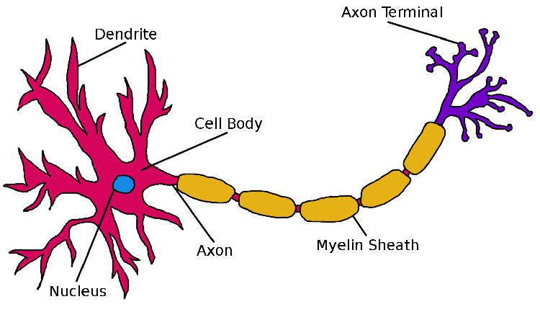

Neurons also have a wide-variety of membrane-spanning ion channels that allow ions to move into and out of the cell. Ion channels control the flow of ions across the cell membrane by opening and closing in response to voltage changes and to both internal and external signals. Ions flow into and out of a cell due to the voltage and the concentration gradients.

The membrane potential is the difference in electrical potential between:
- Interior of a neuron: the potential inside is about -70mV (relative to the surrounding)
- Surrounding extracellular medium: set to 0 mV (conventionally chosen)

- If the inside has a negative electrical potential with respect to the outside we say that the cell is polarized.
- If positive charged ions flow out of the cell (or negative charged ions flow into the cell) the membrane potential becomes more negative, aka hyperpolarization.
- If the membrane potential changes and becomes less negative (or even positive) it is called depolarization.
  - If we reach a threshold of the membrane potential a positive feedback process is initiated ⟹ the neuron generates an action potential.

An action potential is around 100 mV fluctuation (usually from -70mV to +40mV) in the electrical potential across the cell membrane that lasts for about 1 ms.
- Absolute refractory period: action potential generation depends on recent history of cell firing. For a few milliseconds just after an action potential has been fired it is impossible to initiate another spike.
- Relative refractory period: tens of milliseconds after a spike, difficult (but not impossible) to evoke an action potential.
An action potential is the only form of membrane potential fluctuation that can propagate over large distances without attenuation.

Recording Neural Responses
- Membrane potentials are measured intracellularly with a hollow glass electrode and compare the potential it records with that of a reference electrode placed in the extracellular medium.
- Intracellular recording made with sharp electrodes inserted through the membrane into the cell or patch electrodes that broader tips are sealed tightly to the surface of the membrane.

Model Neurons I: Neuroelectronics
The cell membrane is a lipid bilayer of 4 nm thick that is impermeable. It acts as a capacitor by separating the charges inside from the charges outside the cell. Embedded in the cell membrane, we also have ion-conducting channels which lower the effective membrane resistance.

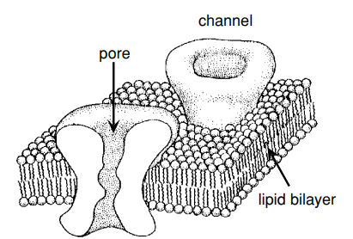

The membrane conductance depends also on the density and type of ion channels. We have many selective channels that allow only a single type of ions to pass through them.

- When a neuron is inactive the excess internal negative charge causes the potential inside the cell membrane to be negative ⟹ is a potential equilibrium point at which the flow of ions into the cell matches that out of the cell.
  - The membrane potential can change if the balance of ion flow is modified by opening or closing of ions channels.

$V_{T} = \frac{RT}{F} = \frac{k_{B}T}{q}$
- $V_{T}$ is the thermal voltage aka the potential difference across a membrane

Thermal energy of an ion:
- Thermal energy of an ion: $k_{B}T$ where
  - $k_{B}$ is the Boltzmann constant
  - $T$ is the temperature in Kelvin (K)
  - $q$ is the charge of the ion.

Or we can use thermal energy for a mole of ions:
  - R universal gas constant $R = 8.31 joules/ mol K = 1.99 cal /mol K$
  - $T$ is the temperature in Kelvin (K)
  - $F$ is the Faraday constant $F = 96480 coulombs/mol$

Membrane capacitance and resistance
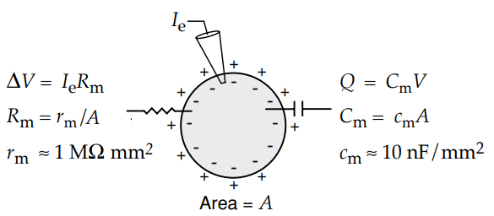
$Q = C_{m}V$ (standard equation for a capacitor)
  - $Q$ is the charge
  - $C_{m}$ is the capacitance created by the cell membrane
  - $V$ is the voltage across the membrane

Also,
$C_{m} = c_{m}A$
- $C_{m}$ is the capacitance created by the cell membrane
- $c_{m}$ is the capacitance per unit area of membrane $c_{m} = 10 nF / mm^{2}$ is approximately the same for all neurons
- $A$ is the surface area

$C_{m}\frac{dV}{dt}=\frac{dQ}{dt}$ ⇐ relation between the membrane capacitance $C_{m}$ and the amount of current required to change the membrane potential at a given rate.

Equilibrium and Reversal Potential
- Why neurons move from inside and outside the cell
  - Voltage difference between interior and exterior of cell produces forces on ions
  - Negative membrane potentials attract positive ions in the neuron and repel negative ions
  - Ions concentration differ inside and outside the neuron
    - Na⁺ and Ca²⁺ more outside than inside a cell ⟹ ions are driven in the neuron by diffusion (diffusion: movement of ions from an area of higher concentration to an area of lower concentration, aka go where they are less)
    - K⁺ more inside than outside the neuron ⟹ ions are driven out of the neuron by diffusion

Equilibrium potential E: (see later) membrane potential at which current flow due to electric forces cancel the diffusive flow. It's the voltage at which the tendency of an ion to move into the cell (due to concentration differences) is perfectly balanced by its tendency to move out (due to the electrical charge difference). The flow due to electrical forces is canceled out by the flow due to concentration differences (diffusion).

- Negative membrane potential ⟹ Is the difference in electrical charge between the inside and outside of the cell, in this case the inside of the cell is more negative compared to the outside
- Positive charged ion: like Na⁺ or K⁺ ⟹ are attracted to the negative charged interior of the cell
- Thermal energy of an ion $V_{T} = \frac{k_{B}T}{q}$: energy that ions have due to their temperature-dependent motion. An ion to cross the membrane needs to have enough thermal energy to overcome the electrical barrier of the membrane. The amount of thermal energy an ion has is related to the temperature T of the environment.

Example:
- Consider a neuron at rest, which typically has a membrane potential of around -70 mV (the inside is more negative than the outside).
- Potassium ions (K⁺), which are positively charged, are more concentrated inside the neuron than outside.
- Under normal circumstances, K⁺ ions would tend to leave the cell due to the concentration gradient (from higher concentration inside to lower concentration outside).
- However, the negative membrane potential creates an electrical force that attracts K⁺ ions back into the cell.
- For K⁺ ions to actually leave the cell, they must have enough thermal energy to overcome the electrical attraction pulling them inward.

- Ions electric charge zq:
  - q is the charge of one proton
  - z is the valence of the ion, aka how many charges it carries (Na²⁺ would have z = +2)
- If the membrane potential is negative (V < 0), a positive ion (z > 0) must overcome this negative potential to move from inside to outside.
- The minimum energy required is -zqV (note: the value is positive because V is negative and zq is positive).
- The probability of an ion to have enough thermal energy to cross the membrane is $exp(zqV / k_{B}T)$ where T is the absolute temperature in Kelvin of the environment where the ion movement is occurring (inside and outside the temperature is essentially the same).
- The probability of a mole of ion to have enough thermal energy to cross the membrane is $exp(zFV / RT)$ .

Opposing concentration gradient
At some point the movement of ions into the cell and out of the cell can balance each other out. This happens at a specific electrical potential called the equilibrium potential (E).

- $[outside] = [inside] exp(zE/V_{T})$
  - $[outside]$ and $[inside]$ refers to the ions concentration of a particular ion outside and inside the cell.
    - $z$ is the valence of the ion (aka the electrical charge)
    - $E$ is the equilibrium potential (membrane potential at which there's no net flow of the ion in or out the cell)
    - $V_{T}$ is the thermal voltage
    - $exp(zE/V_{T})$ is the Boltzmann factor which accounts for the effect of the membrane potential of the ion’s movement.
  - The concentration of ions outside the cell is equal to the concentration inside the cell times the probability of a mole of ions of having enough thermal energy to cross the membrane $exp(zFV / RT)$ (accounting for the energy needed to move against the electrical potential).

Nernst equation
It is used to calculate the equilibrium potential (E) for a specific type of ion based on the concentration of that ion inside and outside the cell. It calculates the voltage (membrane potential) at which the net flow of ions across the membrane is zero.
$E = \frac{V_{T}}{z}ln\left(\frac{[outside]}{[inside]}\right)$

Different ions have different equilibrium potential E
- Potassium K⁺ ⟹ E_{k} ranges between -70 and -90mV
- Sodium Na⁺ ⟹ E_{Na} ranges +50 mV or higher
- Calcium Ca²⁺ ⟹ E_{Ca} around +150 mV
- Chloride Cl⁻ ⟹ E_{Cl} ranges between -60 and -65 mV

⟹ Nernst equation is specific for channels that allow to pass through only one type of ion (selective channels). It's used when a channel allows only a single kind of ion (like potassium, sodium, calcium, or chloride) to pass through it.

However, not all ion channels are selective, some channels allow multiple types of ions to pass through, and so we can not use the Nernst equation for non-selective channels. In this case, we use the Goldman equation to estimate $E$.
- NOTE: in this case with non-selective channels rather than calling $E$ as equilibrium potential we call it reversal potential. $E$ take a value that is intermediate between the equilibrium potential of the individual ions.
- NOTE: the direction of current flow through the channel switches as the membrane potential pass through $E$.

Remember: V is the neuron’s membrane potential while E is the reversal potential
- V > E ⟹ positive ions will flow out of the neuron
- V < E ⟹ positive ions will flow into the neuron

- Na⁺ and Ca²⁺ have positive reversal potential (aka their reversal potential is higher than the neuron’s typical resting potential which is usually around -70mV) and they tend to depolarize the neuron (aka reduce the difference in electrical charge between the inside and outside of the neuron’s cell membrane).
  - Na⁺ and Ca²⁺ have higher concentration outside the cell rather than inside, so when the channels are open they will flow inside the neuron and this makes the inside of the neuron less negative (depolarization), it reduces the difference in charge between the inside and outside of the neuron.
- K⁺ have a negative reversal potential, it is more inside than outside the neuron, when the channels are open they will flow out of the neuron by moving from a higher concentration to a lower concentration location. This makes the inside of the neuron more negative (hyperpolarization).
- Cl⁻ have reversal potential close to the neuron’s resting membrane potential (-70 mV). Because of this Cl⁻ does not significantly change the membrane potential. It changes the membrane resistance of the cell. It makes shunting conductance, aka makes the neuron less responsive to other input (like Na⁺ or K⁺) by increasing the membrane’s conductance. Shunting helps to stabilize the neuron’s activity, preventing excessive reactions to small inputs. It's a way in which the neuron can regulate how it responds to various signals, ensuring it doesn't get overly excited or inhibited by minor changes.
  - Unlike Na⁺ or K⁺ opening Cl⁻ channels does not significantly make the neuron more negative (hyperpolarize) or less negative (depolarize).

- Every synapse (aka the point of communication between two neurons) has a characteristic reversal potential (E). This is the membrane potential at which the direction of the ionic current through the synaptic channels reverses.
  - Inhibitory synapses: synapses with reversal potential less than the threshold needed to generate an action potential. These synapses inhibit the neuron's activity. Lower the likelihood of a neuron firing an action potential.
  - Excitatory synapses: synapses with reversal potential above threshold for action potential generation. These synapses excite or activate the neuron's activity. Increase the likelihood of a neuron firing an action potential.

The membrane Current
Membrane current: total current flowing across the membrane of the neuron through all of its ion channels. By convention
- The membrane current is positive when positive ions leave the neuron
- The membrane current is negative when positive ions enter the neuron

The total membrane current is computed by summing currents due to all of the different types of channels within the cell membrane, including voltage-dependent and synaptic channels.

It is more common to use membrane current per unit area called i_{m} (also because it allows comparison of neurons of different size). If we want to obtain the membrane current it is sufficient to multiply the membrane current per unit area with A that is the total surface area of the cell.
$Membrane current = i_{m}A$

- i represent different types of channels and E_{i} is the reversal potential for that type of channel. As an example if i = Na then E_{Na} is the reversal potential of the sodium channel.
- Also when V (neuron’s membrane potential) is equal to E_{i} (reversal potential) of a particular type of ion channel (like sodium E_{Na}) then the two forces are in balance and there's no net movement of ions, and thus, no net current flows through those channels.

- $V - E_{i}$ is the driving force, it is the difference between the membrane potential V and the reversal potential E_{i} for each type of ion. This difference determines the direction and magnitude of the current for each type of ion channel. If V > E_{i} ions flow in one direction (positive ions will flow out of the neuron), if V < E_{i} ions flow in the opposite direction (positive ions will flow into the neuron).
- The membrane current per unit area due to the type i channels is written as $g_{i}\left(V - E_{i}\right)$.
- $g_{i}$ is the specific conductance for ions of type i. It measures how easily ions can flow through this channel. Different ion channels allow ions to pass through at different rates, g_{i} quantifies this for each type of channel.

$i_{m} = \sum_{i}{}g_{i}\left(V - E_{i}\right)$
Since some factors that contribute to the total membrane current are constant over time it is useful to group them together in a single term called leakage current. Ions pumps are generally assumed to work at a steady rate, and so the current they generate does not change much over time and so can be included in a time-independent leakage conductance $\underline{g_{L}}$.

$\underline{g_{L}} \left(V - E_{L}\right)$
- $\underline{g_{L}}$ is constant, it is kept as a free parameter to match the conductance at rest
- $E_{L}$ is not equal to the equilibrium potential of any particular ion, it is kept as a free parameter and adjusted to make the resting potential of the model neuron match that of the cell being studied.

Electrical property
Different ions channels with various kinetic and selectivity filters which significantly influence the neuron’s electrical properties. There are some key factors that determine the electrical properties of neurons such as:
- Kinetics of each ion channel: how quickly and in response to what stimuli the ion channels open or close
- Combination of ion channels: types and number of ion channels present in the neuron’s membrane
- Location of ion channels: where on the neuron (axon, dendrites, soma) these channels are located
- Relative conductance of each ion channel: how easily ions can pass through these channels.

To study and measure electrical properties of a neuron there are several methods with its own limitation:
- Brain slices: cut the brain in sections that are used for microscopic examination. The limitation is that when the brain is sliced there are still some connections untouched but some are cut and there is a lack of the full context of a living brain and furthermore it might affect neurons’ natural functioning.
- Patch-clamp: a tiny glass pipette is used to isolate and record the electrical currents from individual ion channels in a neuron’s membrane. The limitation is that it can record only from a few neurons at a time and so it limits the amount of data that can be collected simultaneously.

Behavior determined by ion channels:
- At rest: certain potassium channels (K2p Kir) are open to maintain the resting potential. Kir are inward reflecting (allow potassium ions K⁺ to move into the neuron more easily.
- During depolarization: voltage-gated sodium Nav and calcium Cav channels are open, they allow Na⁺ and Ca²⁺ into the neuron (leading to depolarization).
- During hyperpolarization: voltage-gated potassium channels (Kv) are open, allow K⁺ ions out of the neuron. Calcium-activated potassium channels Kca contribute to redepolarizing the membrane.

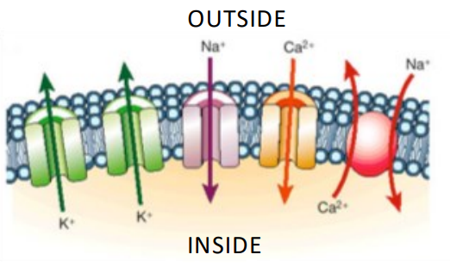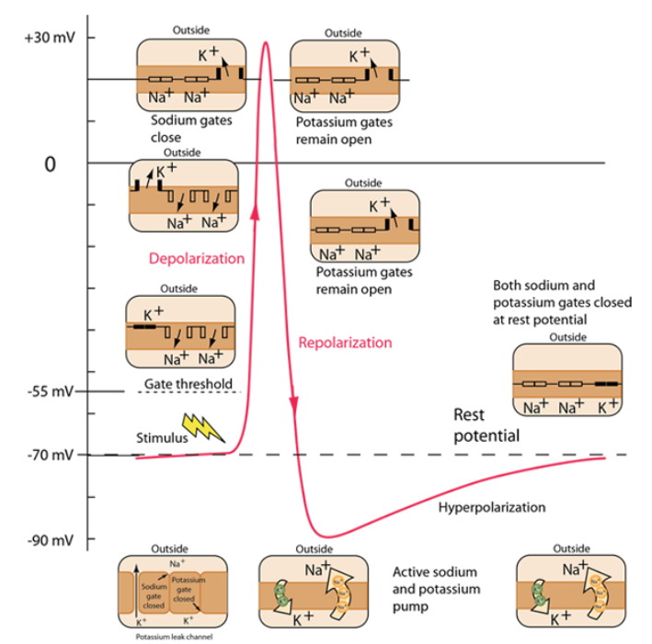

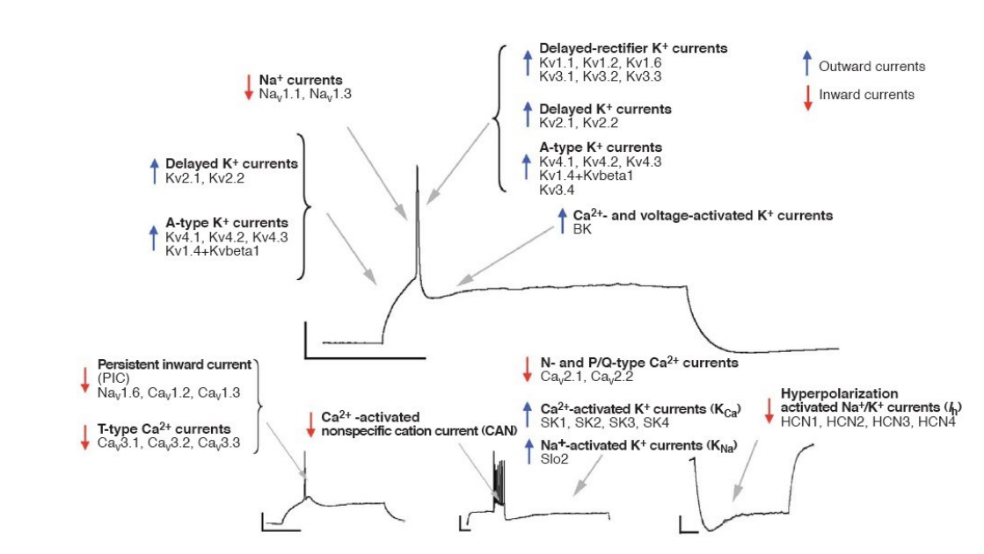

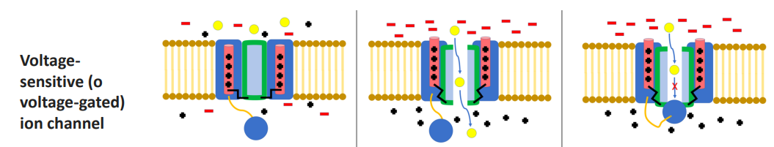

Channels are characterized by their state, including deactivated (returning to closed state post-activation), activated (opening in response to voltage changes) and inactivated (ion flow is blocked by mechanisms other than closing such as “ball and chain” model).

Intracellular resistance - p.172
Intracellular resistance: resistance against the flow of ions inside the neuron’s cellular structure.

- The membrane potential (V) can vary between different part of a neuron (soma [cell body], dendrites and axon)
- This difference in potential can cause ions to flow inside the neuron attempting to equalize the potential across these areas
- The intracellular medium (cytoplasm) provides resistance to the flow of these ions. In particular the resistance is highest for long, narrow stretches of dendritic or axonal cable.

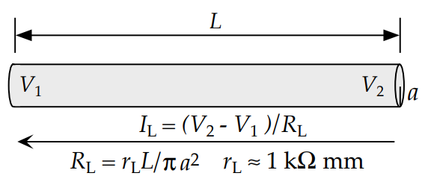

- Longitudinal current I_{L}: is the current flowing along the length of a neuron segment (like a dendrite or axon) $I_{L} = \left(V_{2} - V_{1}\right) / R_{L}$
- Longitudinal resistance R_{L}: is the resistance along the length of a neuron segment.
  - It increases with the length of the segment ⟹ longer segments have higher resistance
  - It is inversely proportional to the cross-sectional area ⟹ thinner segments have higher resistance
  - $R_{L} = r_{L}L/πa^{2}$
- Intracellular resistivity r_{L}: constant representing the resistivity of the intracellular environment typically ranges from 1 to 3 kΩmm

Space constant λ
The space constant λ is a parameter that describes how far an electrical signal can travel along a neuron before it decays significantly.

$λ = \sqrt{\frac{dR_{m}}{4R_{i}}}$
- Diameter of the axon d: diameter of the axon, a larger diameter results in a larger space constant, meaning that electrical signals can travel further along the axon before decaying
- Membrane resistance R_{m}: resistance of the neuron’s membrane to the flow of electrical current across it. Higher R_{m} means the membrane is more resistant to ion flow across it, which can be linked to better insulation
- Intracellular resistance R_{i}: is the resistance to the flow of electrical current along the inside of the axon. Indicate how easily charges (ions) can move longitudinally inside the axon

The passive properties of membranes and axon diameter affect the speed of conduction of action potentials
- The speed of conduction of action potential is inversely related to r_{i} * c_{m}. High r_{i} and c_{m} slow down the conduction speed
  - Intracellular resistance per unit area r_{i}
  - Membrane capacitance per unit area c_{m}

Time constant τ
$τ_{m}$ represent how quickly the membrane potential can change in response to input. Smaller $τ_{m}$ means that the membrane potential can change more rapidly, facilitating faster propagation of action potentials.

$τ_{m}= R_{m}C_{m}$
- Membrane resistance $R_{m}$
- Membrane capacitance $C_{m}$

The space constant λ is directly proportional to the propagation velocity. A larger space constant λ means that the action potential can travel further along the axon without significant loss of signal strength.
- To double the velocity it is necessary to quadruple the diameter d of the axon.

Myelin
- Adding a thick sheath of myelin leads to the decrease of membrane capacitance C_{m} and it allows faster signal transmission. But adding myelin would cover voltage-dependent Na⁺ channels and if those are occluded it is impossible to generate an action potential. So, instead of coating the entire axon with the myelin, only sections are coated and some regions called nodes are left bare.
- Myelin can increase the membrane resistance R_{m}, this reduces the leakage of current across the axon’s membrane, allowing the electrical signal to travel more efficiently along the axon.
- Myelin also decreases the membrane capacitance C_{m}, this means that the membrane can change its voltage more quickly in response to a given amount of charge, facilitating faster signal transmission.
- Myelin is essential for normal motor function (movement such as walking) and sensory function (hearing, seeing, …).
- Multiple sclerosis (MS) affects the central nervous system and is the best known disorder of myelin.

Lezione 4/5

Introduction - p.20
- Neurons have the ability to propagate signals rapidly over large distances. Are highly specialized for generating electrical signals in response to chemical and other inputs and transmitting them to other cells.
- Communicate by generating electrical pulses (aka action potentials), those are spikes that can travel down nerve fibers. Neurons communicate by firing sequences of spikes in various temporal patterns.
- The structure of the dendritic tree allows a neuron to receive inputs from many other neurons through synaptic connections
- Neural encoding: map from stimulus to response. Measuring and characterizing how stimulus attributes (such as light or sound intensity) are represented by action potentials.
- Neural decoding: map from response to stimulus. Reconstruct a stimulus from the spike sequences it evokes.

- If a neuron is depolarized (aka the membrane potential becomes less negative or even positive) sufficiently to raise the membrane potential above a threshold ⟹ action potential + absolute and relative refractory periods.
  - Once the threshold is surpassed a positive feedback mechanism kicks in. The voltage-gated ion channels open in response to the depolarization allowing more ions to flow across the membrane and further depolarize the neuron.
  - An action potential is a brief event, typically lasting about 1 millisecond, during this time the membrane potential rapidly rises and then falls, which is seen as a spike when measured.
- After the action potential occurs we have a refractory period during which the neuron is less responsive to stimuli. It is divided in two phases
- Absolute refractory period: few milliseconds immediately following an action potential. It is impossible to initiate another spike
- Relative refractory period: after the absolute refractory period there’s a longer phase (lasting up to tens of milliseconds) where it is possible but more difficult to evoke an action potential.

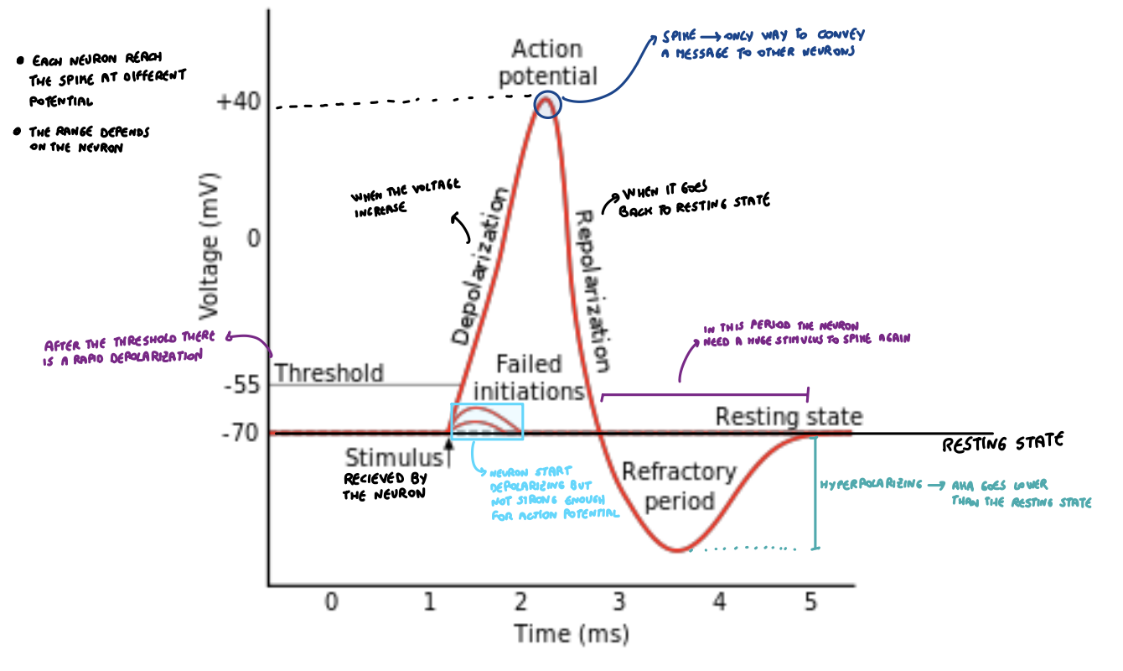

Recording Neuronal Responses - p.23
Two strategies to record electrical neuronal responses:
- Intracellular: mainly for in vitro, for measuring the membrane potential of a neuron form inside the cell. Use a hollow glass electrode, filled with a conducting electrolyte, connected to the neuron. The potential recorded by the electrode is compared with a reference electrode placed in the extracellular medium.
- Extracellular: mainly for in vivo, the electrode is placed close to the neuron but without penetrating the cell membrane. Can misurate the action potential of a neuron but not the subthreshold membrane potential. Use in vivo experiments.

From stimulus to response - p.25
- Neuron responses are complex and variable. Also neurons typically respond by producing complex spike sequences that reflect both the intrinsic dynamics of the neuron and the temporal characteristic of the stimulus. Furthermore, neural responses can vary from trial to trial even when the same stimulus is presented repeatedly.
- Because of this variability of action potential sequences it is very unlikely that we can describe and predict the timing of each spike deterministically. We use a model that can account for the probabilities that different spike sequences are evoked by a specific stimulus.
- We need to examine not only the firing pattern of individual neurons but also the relationship of these firing patterns to each other across the population of responding cells, this is because many neurons respond to the same given stimulus and therefore stimulus features are encoded by activities of large neural populations.

Firing rate and spike-train correlation functions: basic measures of spiking probability and statistics.

Even if action potentials can vary they are treated as identical stereotyped events. If we ignore the brief duration of an action potential (about 1 ms) we can represent an action potential sequence by a list of the times when spikes occurred.
- For n spikes we denote the time of when the spike occurred by t_{i} with i = 1, 2, …, n
- The trial during which the spikes are recorded is taken from time 0 to time T, so 0 ≤ t_{i} ≤ T for all i.
- Neural response function $ρ(t)$: $ρ(t) = \sum_{i = 1}^{n}{}δ\left(t - t_{i}\right)$. We represent the spike sequence as a sum of infinitesimally narrow idealized spikes. The neural response function represents the timing of action potential fired by a neuron; this formula converts the discrete events of neuronal spiking into a continuous function of time.
  - The $δ\left(t\right)$ is the Dirac δ function, this function is zero everywhere except at the point where the neuron fires.

Spike-count rate r
Spike-count rate r: average number of spikes per unit time. Gives the average firing rate
$r = \frac{n}{T}= \frac{1}{T}\int_{0}^{T}{}dτ ρ(τ)$
- Total number of spikes in a trial n
- Duration of the trial T
- The integral sum the neural response function over the trial duration, this effectively counts the number of spikes since $ρ(τ)$ represent spikes as delta functions.

If you have a 10 seconds record activity (T = 10 seconds) with the neuron that fires 50 action potentials (spikes) we have n = 50, so the spike-count rate (r) is 50/10 = 5 spikes / seconds.

Spike time-dependent count rate r(t)
- r(t) is a measure used to understand how the firing rate of a neuron changes over time in response to a stimulus. It is the average firing rate during this interval.
- Unlike the spike-count rate r which gives one number for the whole trial, r(t) varies with time, reflecting how the neuron's firing rate changes at different moments during the trial.

$r(t) = \frac{1}{Δt}\int_{t}^{t+Δt}{}dτ ⟨ρ(τ)⟩$
- The integral calculates the total number of spikes in the time interval from t to t + Δt
- ⟨ρ(τ)⟩ means that you take the neural response function ρ(τ) at each time τ and average it over several trials
- Δt is the duration of this time interval

Average firing rate ⟨r⟩
It is a measure that averages the spike-count rate over multiple trials. It is the average number of spikes per trial (across multiple trials) divided by the trial duration
$⟨r⟩= \frac{⟨n⟩}{T}=\frac{1}{T}\int_{0}^{T}{}dτ ⟨ρ(τ)⟩= \frac{1}{T}\int_{0}^{T}{}dt r(t)$
- ⟨n⟩ is the average number of spikes per trial
- T is the duration of the trial
- ⟨ρ(τ)⟩ is trial-averaged neural response function

If you have 5 trials of 10 seconds each with 50, 60, 55, 65 and 45 total spikes than ⟨n⟩ = (50+60+55+65+45) / 5 = 55 and ⟨r⟩ = 55 spikes / 10 seconds = 5.5 spikes/second

NOTE: the term firing rate is commonly used for all three quantities:
- r(t) ⟹ if possible we call it firing rate
- r ⟹ if possible we call it spike-count rate
- ⟨r⟩ ⟹ if possible we call it average firing rate

Measuring firing rate - p.28
The firing rate r(t) can not be determined exactly from the limited data available from a finite number of trials. Also there is no unique way to approximate the firing rate r(t).

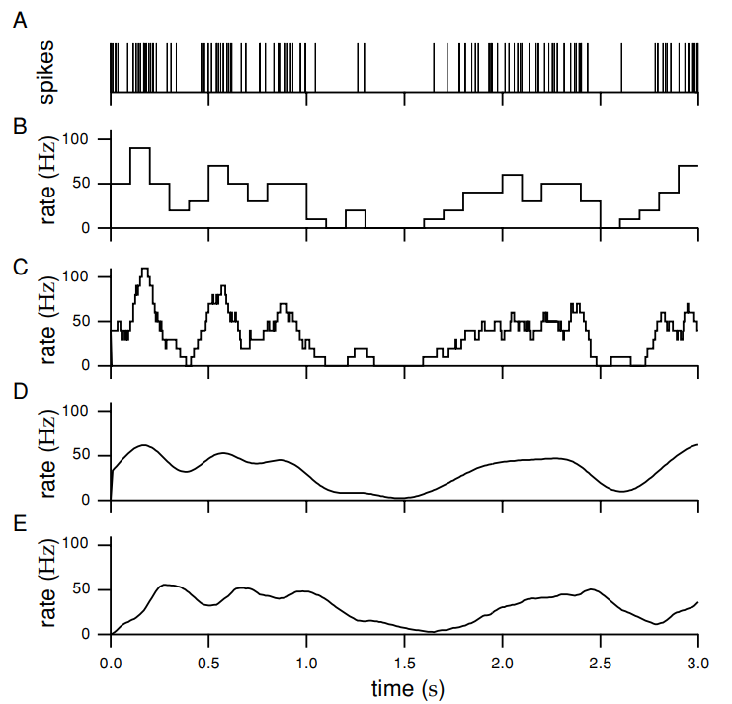
Different ways to approximate r(t) from a spike sequence.
- Spike train recorded from the inferotemporal cortex of a monkey
- Divide time in discrete bins of duration Δt (in this case 100 ns) and we count the number of spikes within each bin and divide by Δt. It estimates the firing rate that is a piecewise constant function of time, resembling a histogram. Decreasing Δt will increase the temporal resolution and it will provide an estimate of the firing rate at more finely spaced intervals of time but also with smaller bins there are few spikes in each bin, and this makes it harder to accurately estimate the firing rate (leads to more variability from bin to bin).
- To overcome this issue (called quantized firing rate) is to vary the bin size so that a fixed number of spikes appear in each bin, also the firing rate is then approximated as that fixed number of spikes divided by the variable bin width.
- To avoid the arbitrariness of placement of the bins of point B) we can instead take a single bin or window of duration Δt and slide it along the spike train, counting the number of spikes within the window at each location (in the example Δt = 100 ms).
- The firing rate is expressed as the sum of a window function over the times t_{i} for i = 1,2,..., n where n spikes in a particular sequence occurred
- $r_{approx}(t) = \sum_{i=1}^{n}{}w\left(t - t_{i}\right) OR r_{approx}(t) =\int_{-∞}^{+∞}{}dτ w(τ)ρ(t-τ)$ where the window function is 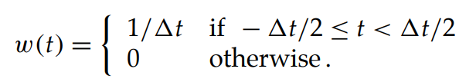
- However it is important to remember that one bin width is correlated with the other close by because they involve some of the same spikes.
- The integral in the formula is called linear filter and the window function is called filter kernel

- Instead of the rectangular window function of point C) we can use a window function (filter kernel such as) 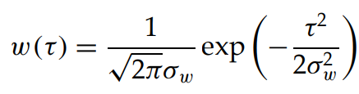 this filter kernel is a gaussian where δ_{w} controls the temporal resolution of the resulting rate (it plays an analogous role to Δt). This generates a firing-rate that is a smooth function of time.
- The issue with the rectangular and gaussian window function is that it estimates the firing rate by using spikes fired before and after the current time point being analyzed. This might not reflect the real-time processing capabilities of neurons.
- Use the window function (filter kernel) such as 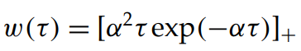 that is equal to α²τexp(-ατ) (itself) if it is positive and 0 if it is negative.
- Note that this tends to peak later than D) using a temporally symmetric window function.

Tuning curves - p.31
- Neuronal response typically depends on many different properties of a stimulus. But now we consider responses of neurons as a function of just one of the stimulus attributes (denoted by s) to which they may be sensitive.
- Count action potentials fired during the presentation of the stimulus to characterize the response of a neuron.
- If we average the number of action potentials fired over many trials we obtain the average firing rate ⟨r⟩. The average firing rate ⟨r⟩ is defined as a function of the stimulus attribute s ⟹ ⟨r⟩ = f(s) and it is called neural response tuning curve and it depends on the parameter s used to describe the stimulus.
- Because tuning curves correspond to firing rates they are measured in unit spikes per second or Hz. Aka how many spikes appear in a second.
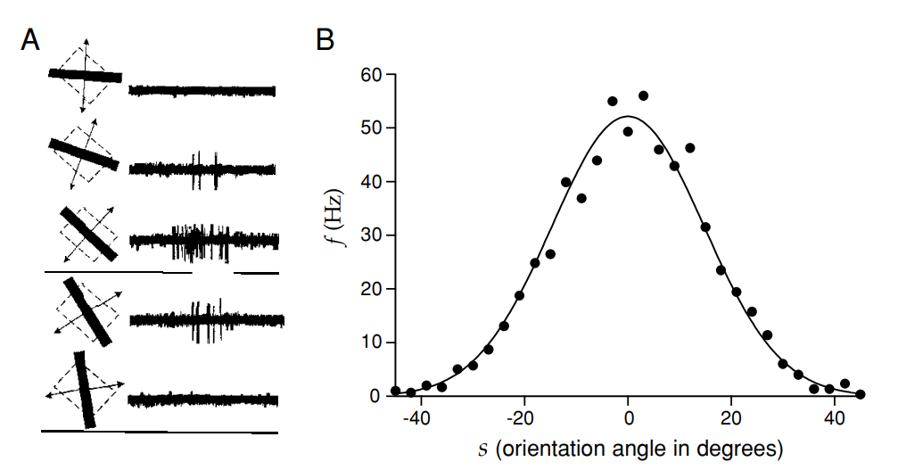
Image:
- Extracellular recording of a neuron in the primary visual cortex of a monkey. Bar of light was moved at different angles across the region of the visual field where the cell responded to light (called the receptive field of the neuron).
- The number of action potentials fired depends on the angle of orientation of the bar.

$f(s) = r_{max}exp\left(-\frac{1}{2}{\left(\frac{s-s_{max}}{σ_{f}}\right)}^{2}\right)$ the formula is used to model how the firing rate of a neuron changes with respect to the orientation angle of the visual stimulus (the bar of light). The gaussian shape of the curve reflects that the neuron’s response gradually falls off as the stimulus orientation deviates from s_{max}.
- $f(s)$ is the neuron firing rate as a function of the stimulus orientation angle s.
- r_{max} is the maximum average response rate of the neuron. Is the highest firing rate that the neuron achieves for any stimulus orientation.
- s is the orientation angle of the light bar during a particular trial.
- s_{max} is the orientation angle that evokes the maximum response r_{max} from the neuron. It is called preferred orientation because the neuron responds most strongly to this angle.
- σ_{f} determines the width of the tuning curve. A smaller σ_{f} indicates the neuron is more selectively responsive to orientations close to s_{max}

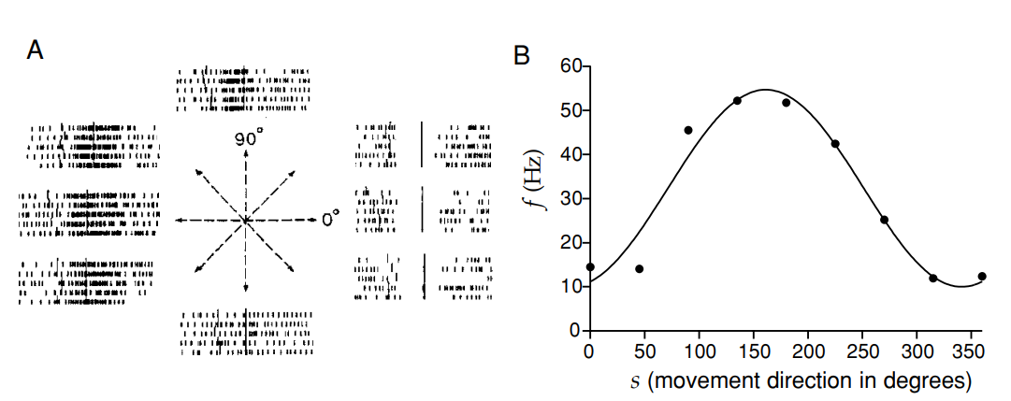
Extracellular recording from a neuron in the primary motor cortex in a monkey that has been trained to reach in different locations, five different trials.
- The firing pattern of the cell (in particular the rate at which spikes are generated) is correlated with the direction of arm movement.
- Average firing rate of a V1 neuron depends on retinal disparity
$f(s) = {\left[r_{0}+ \left(r_{max} - r_{0}\right)cos\left(s - s_{max}\right)\right]}_{+}$
- f(s) is the neuron firing rate for a given arm movement direction
- s is the reaching angle of the arm
- r_{max} maximum firing rate observed when the arm moves in the neuron’s preferred direction (s_{max})
- s_{max} reaching angle associated with the maximum response (r_{max})
- r₀ offset or background firing rate

Because firing rate can not be negative, the cosine tuning curve must be half-wave rectified in this case.

Retinal disparity: difference in retinal location of an image between the two eyes. Some neurons are sensitive to disparity, representing an early stage in the representation of viewing distance.

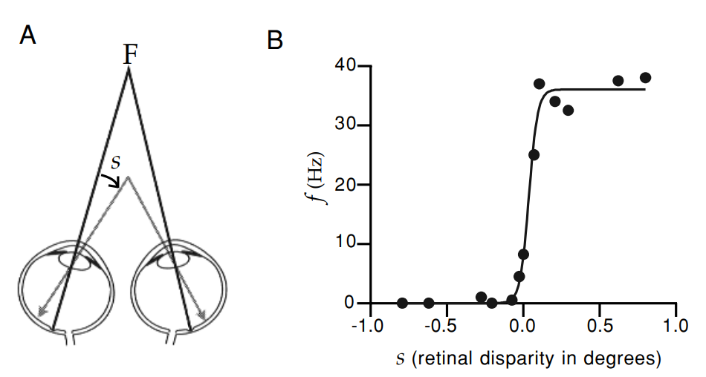
The data points are now fitted with a tuning curve called logistic or sigmoidal function
$f(s) = \frac{r_{max}}{1 + exp\left(\left(s_{1/2}-s\right)/Δ_{s}\right)}$
- s is the retinal disparity
- s_{1/2} is the disparity that produces a firing rate half as big as the maximum value r_{max}.
- Δ_{s} controls the rate at which firing rate changes with disparity. If Δ_{s} is negative the firing rate decreases with increasing s, instead of increasing

Spike-count variability - p.33
Tuning curves allow to predict the average firing rate, but they do not describe how the spike-count firing rate r varies about its mean value ⟨r⟩= f(s) from trial to trial. The tuning curves do not capture the variability in the spike-count firing rate (r) from trial to trial.

- Single-trial responses, like spike-count rates, are better modeled probabilistically rather than deterministically. The firing rate r for each trial is considered to be drawn from a probability distribution with the mean f(s).
- The trial-to-trial deviation of r from f(s) is considered to be noise, we have two type of noise:
  - Additive noise: the variability (standard deviation) is independent of the mean firing rate f(s). Aka the amount of noise is constant, regardless of the firing rate.
    - Example: Imagine a neuron typically fires 20 spikes in response to a certain stimulus. Due to additive noise, the actual number of spikes might vary by a constant number (say, ±3 spikes) each time. So, in different trials, you might observe 17, 23, 20, 19, etc., spikes, regardless of any changes in the stimulus.
  - Multiplicative noise: the variability is proportional to the mean firing rate f(s). Aka higher firing rates have greater variability.
    - Example: Let's say the neuron fires 10 spikes on average for a low-intensity stimulus and 50 spikes for a high-intensity stimulus. With multiplicative noise, the variation for the low-intensity stimulus might be ±2 spikes (8 to 12 spikes), while for the high-intensity stimulus, it could be ±10 spikes (40 to 60 spikes). The variability is "multiplying" as the average response rate increases.

Use a stochastic (random) spike generator. Takes a deterministic estimate of the firing rate r_{est}(t) and produces a stochastic spiking pattern from it. This approach accounts for the fact that even under constant estimated firing rate, the actual pattern of spikes can be different in each trial.

1.3 What makes a neuron fire? - p.34
Neurons in the brain respond to various stimuli (like light, sound, touch, …). Scientists use response tuning curves to understand how different levels or types of stimuli affect the average response of a neuron. These curves plot the stimulus against the neuron’s response, helping to identify which stimuli the neuron is most sensitive to.

Response tuning curves: are curves that show how a neuron’s average response varies with different stimuli (for example: a neuron might fire more rapidly in response to bright light than to dim light).

Spike-Triggered averaging: method used to understand what specific features of a stimulus make a neuron fire an action potential.
- Choosing a trigger: aka firing an action potential. It is important to decide a consistent event or response that will serve as our trigger for analysis.
- Looking backwards: once a neuron fires, researchers look backward in time to see what the stimulus was like just before the action potential occurred.
- Averaging the stimuli: collect data from many such instances.
- Analyzing the average stimulus: the average stimulus gives insight into what characteristics of the stimulus are most likely to make the neuron fire.
⟹ Spike-triggered averaging are useful to understand the selectivity of a neuron. It tells us what specific aspects of a stimulus (like intensity, frequency, …) are effective in triggering a response from the neuron. The spike-triggered averaging is a powerful tool that reveals the neuron’s selectivity on what it is “tuned” to respond to.
⟹ When discussing stimuli they are often represented by a parameter s(t) that changes over time.

Describing the Stimulus - p.35
- Dynamic range of stimuli: sensory stimuli can vary greatly. For example, photoreceptors in the retina can respond to single photons and also work in very bright light where millions of photons are hitting every second. They deal with a wide-range of stimuli.
- Sensory neurons are often more responsive to rapid changes in stimuli properties than to a constant level of stimulus. (For example, you are more likely to notice a light flickering than one that’s steadily on).
- When stimuli are constant neurons respond isn’t linear, it is compressed and it follows a logarithmic relationship. This means that as the intensity of the stimulus increases, the increase in the neuron’s response is less dramatic.

- Weber’s law: measure how different the intensity of two stimuli had to be for them to be reliably discriminated. Find the smallest noticeable difference in a stimulus’s intensity is proportional to the intensity of the stimulus itself.
  - For a given stimulus, Δs is proportional to the magnitude of the stimulus s ⟹ so Δs / s is constant.
  - Δs: is the smallest change in the intensity of a stimulus that can be detected by a sensory system (like the smallest increase in weight that you can feel when holding an object).
  - s: magnitude of the original stimulus.

- Fechner’s law: extension of Weber’s law. Suggest that our perceived intensity of a stimulus is related to the logarithm of its actual intensity.

- Sensory systems (vision, hearing, touch, …) are highly adaptive, they adjust to the average intensity of stimuli they encounter. The system “tune out” the constant information to become more sensitive to changes or new stimuli (like when entering a dimly lit room, initially it’s hard to see, but after some time your eyes adapt and you can see more clearly).
- s(t) is defined in such a way that its average value over the duration of a trial is zero. Aka $\int_{0}^{T}{}s(t) dt/T = 0$ where T is the trial duration. This means that over the course of a trial the stimulus values fluctuate around a mean level, which is set to zero for analytical convenience.
  - s(t) stimulus intensity at time t.
  - T: total duration of the time period.
  - The formula is used in experiments where researchers want to focus on changes in stimulus intensity rather than the absolute value.

We have two different types of average:
- Average over repeated trials (same stimulus): use angle brackets ⟨⟩.
- Average over different stimuli: instead of a different notation we can string together all of the stimuli we wish to consider into a single time-dependent stimulus sequence and average over time. Stimulus averages are replaced by time averages.

- It is assumed that the response in a trial depends only on the stimulus values during that trial.
- For simplification we use a property called time-translation invariance ⟹ this means that the result of integrating a function h over the stimulus s(t) should be the same regardless of when the integration starts and ends.

The spike-Triggered Average - p.36
Spike-triggered average C(τ): average value of the stimulus a time interval τ before a spike is fired.

- For a spike occurring at time t_{i} we determine s(t_{i} - τ) and then we sum over all n spikes in a trial i = 1, 2, …, n and divide the total by n.
- If n is large the total number of spikes on each trial is well approximated by the average number of spikes per trial n ≈ ⟨n⟩
  - This approximation allows us to relate the spike-triggered average to other quantities commonly used to characterize the relationship between stimulus and response.
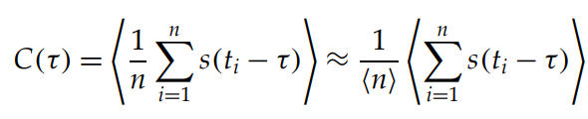

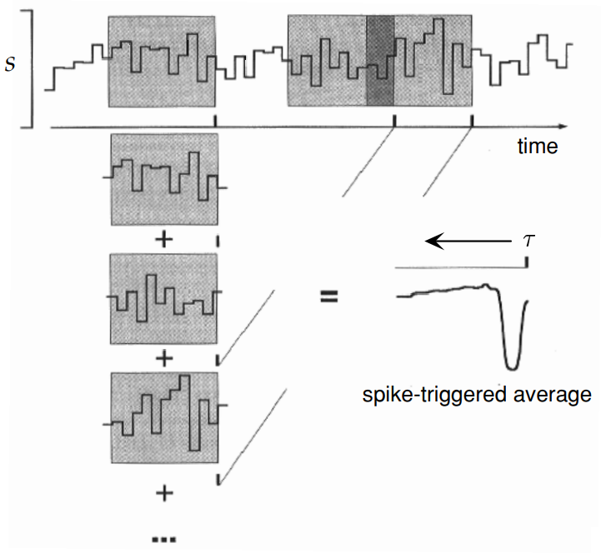

- Each time a spike appears the stimulus in a time window preceding the spike is recorded.
- While the range of τ values in the formula is theoretically unlimited, in practice, the neuron's response is typically influenced by the stimulus within a few hundred milliseconds immediately before the spike.

When τ (time interval before a spike) is larger than the correlation time (how long a stimulus influences neural activity) between the stimulus and the response, C(τ) is expected to approach zero. Essentially, the neuron “forgets” stimuli after the correlation time has elapsed.

We expect C(τ) to approach 0 for positive τ values larger than the correlation time between the stimulus and the response. If the stimulus has no temporal correlation with itself, we also expect C(τ) to be 0 for τ < 0, because the response of a neuron cannot depend on future stimuli.

Spike-triggered average stimulus is often called the reverse correlation function. It is proportional to the correlation of the firing rate with the stimulus at preceding times.

The spike-triggered average stimulus is used to study and characterize neural responses. Since C(τ) is the average value of the stimulus at a time τ before a spike, larger values of τ represent times farther in the past relative to the time of the triggering spike; that is why we plot spike-triggered averages with the time axis going backward compared to the normal convention.

!!!riprendere pag 36 pdf slide 16 della lezione 4

Multiple-Spike-Triggered Averages and Spike-Triggered Correlations
Stimulus averages can be computed by triggering on various combinations of spikes.
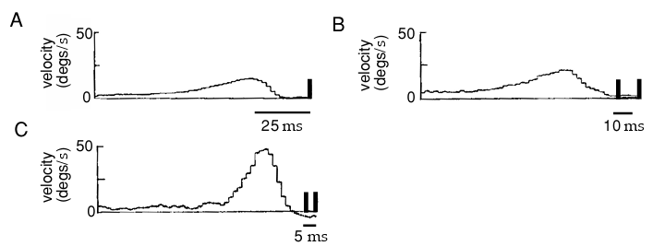
Study on H1 neuron of blowfly (used to detect the motion of visual images during flight in order to generate and guide stabilizing motor corrections). Spike-triggered averages of other stimulus-dependent quantities can provide additional insight into neural encoding, for example, spike-triggered average autocorrelation functions. Obviously, spike-triggered averages of higher-order stimulus combinations can be considered as well.

1.4 Spike-Train Statistics - p.41
Spike times are continuous variables, and, as a result, the probability for a spike to occur at any precisely specified time is actually 0 ⟹ to get a nonzero value ask the probability of a spike to occur within a specified interval (between t and t + Δt).

- Point process: stochastic process that generates a sequence of events (such as action potentials). It could depend on the entire history of preceding events.
- Renewal process: if an event depends only on the immediately preceding event and not the entire history of preceding events.
- Poisson process: no dependence at all on preceding events (aka statistically independent). The occurrence of one event does not affect the likelihood of another event happening. The Poisson process is extremely useful for approximating stochastic neuronal firing.
  - Homogeneous Poisson process: firing rate is constant over time (aka not time-dependent). Simplified model where the neuron fires at a steady unchanging rate regardless of what happened before.
  - Inhomogeneous Poisson process: time-dependent firing rate. The firing rate of a neuron changes over time. It is a more realistic model since it accounts that neuron’s activity is not uniform and is influenced by external and internal factors.

The homogeneous Poisson Process - p.42
We denote the firing rate for a homogeneous Poisson process by r(t) = r, because it’s independent of time. When the firing rate is constant, this process generates every sequence of n spikes over a fixed time interval with equal probability.

Assuming that the spike times are ordered, the relationship is:
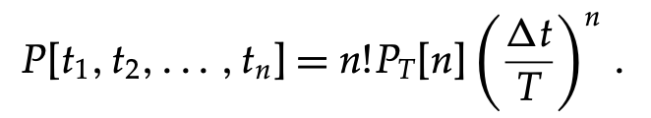
- Probability of observing a particular sequence of spike times t₁, t₂, …, t_{n} under the assumptions that spikes follow a Homogeneous Poisson Process with constant firing rate r.
- $P_{T}[n]$ probability of observing exactly n spikes in a time interval T. To compute it we divide the time T in M bins of size Δt = T/M, we also assume that Δt is small so that the probability of more than one spike inside any of the bin is negligible. $P_{T}[n]$is the product of three factors: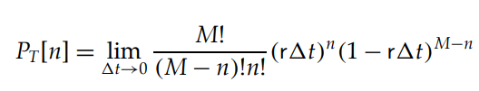
  - ${\left(rΔt\right)}^{n}$ probability of n spikes occurring on n specific bins
  - ${\left(1-rΔt\right)}^{M-n}$ probability of not generating a spike in the remaining M-n bins. (Remember: n is the number of spikes)
  - $\frac{M!}{(M-n)!n!}$ combinatorial factor equal to the number of ways of putting n spikes into M bins

Thanks to some rewritings and math techniques (I actually have no fucking idea page 43 n.1.28) we can write $P_{T}[n]$ as:
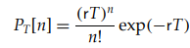
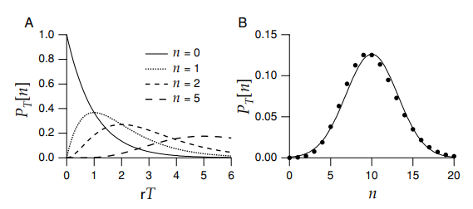
In the left image we have the probabilities of $P_{T}[n]$ for a few n values plotted as a function of rT (rate multiplied by the interval T).
- As rT increases the probability of observing no spikes (n=0) decreases.
- As n increases the probability reaches its maximum at larger T values.
- Large n values are more likely than small ones for large T.
On the right image we can compare the actual Poisson distribution for rT = 10 (the dots) with the Gaussian distribution (the line) with mean and variance equal to 10.

For spikes counted over an interval of duration T, the variance of the spike count is
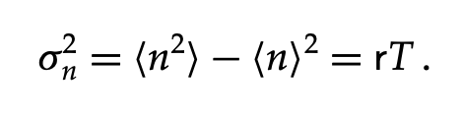
Mean and variance of the spike count are equal. The ratio of these two quantities (aka:$σ_{n}^{2}/⟨n⟩$) is called Fano factor and it takes the value 1 for a homogeneous Poisson process, independent of the time interval T.

The probability density of time intervals between adjacent spikes is called the interspike interval distribution and it is a useful statistic for characterizing spiking patterns. The most likely interspike intervals are short ones, and long intervals have a probability that falls exponentially as function of their duration.

The formula:
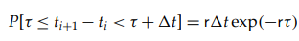
gives the probability that the next spike will occur in a specific time window (τ to τ + Δt) after the previous spike.

Probability density of interspike interval: is the probability without the factor Δt (so $r exp(-rτ)$. So the interspike interval distribution for a homogenous Poisson spike train is an exponential. This also indicates that shorter intervals between spikes are more likely than longer ones.

We can also compute from the interspike interval distribution of a homogeneous Poisson spike train the mean interspike interval:
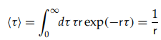

and the variance of interspike intervals:
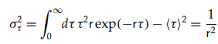

The coefficient of variation C_{V} is the ratio of the standard deviation (square root of variance) and the mean:
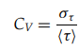

- For a homogeneous Poisson process the coefficient of variation C_{V} is equal to 1. (REMEMBER: also the Fano factor for a homogeneous Poisson process is equal to 1).
- Having a C_{V} of 1 is not enough to confirm that a spike train is Poisson because other processes might also have a C_{V} of 1 but show different higher-order structures in their spike timings. That's why it's a necessary but not a sufficient condition. The same goes for the Fano factor: it's an indicator, but not proof on its own, of a Poisson process.
- For any renewal process the Fano factor evaluated over a long time interval approaches the value C_{v}².

The spike-train autocorrelation function - p.44
- Spike-interval distribution: measure the distribution of times between successive action potentials in a train.
- Spike-train autocorrelation function: autocorrelation of neural response, generalization of spike-train distribution, useful for detecting patterns in spike trains. It is used to analyze the time interval between spikes in a neural spike train.

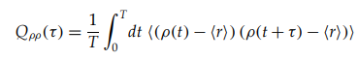
Equation of the spike-train autocorrelation function, it measure how the firing rate of a neuron at one time is related to its firing at another time:
- $ρ(t)$ neural response function at time t
- $⟨r⟩$ average firing rate over time and trials
- $T$ total observation time
- $τ$ time interval between spikes being considered
- NOTE: since this function subtract the average $⟨r⟩$ before computing the correlation it’s technically a “autocovariance” ⟹ but it is still called autocorrelation function.

The spike-train autocorrelation function is constructed from data in the form of a histogram by dividing time into bins.
- Time divided in small intervals (bins) of size Δt
- Each bin is labeled with an integer m determined by the number of times that any two spikes in the train are separated by a time interval lying between (m - 1/2)Δt and (m + 1/2)Δt.
- For each bin we count the number of times two spikes are separated by a time interval within the range for that bin (m - 1/2)Δt and (m + 1/2)Δt.
- If the intervals between the n² spikes pairs in the train were uniformly distributed over the range from 0 to T we would have n²Δt/T intervals in each bin. We subtract n²Δt/T from N_{m} for all m.
- We then divide what we obtain by T.
- The value of the histogram in bin m is H_{m} = N_{m}/T - n²Δt/T².

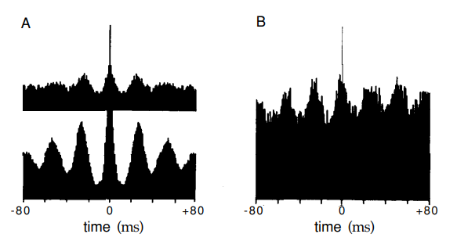

The Inhomogeneous Poisson Process - p.46
When the firing rate depends on time, different sequences of n spikes occur with different probabilities, and p[t₁ , t₂ , . . . , t_{n} ] depends on the spike times.
Since the spikes are still generated independently by an inhomogeneous Poisson process, their times enter into p[t₁ , t₂ , . . . , t_{n} ].
- Unlike the homogeneous Poisson process where events happen with a constant average time, in the inhomogeneous Poisson process the rate can change over time.

Probability density for n spikes time:
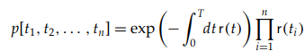
NOTE: this formula assumes that spike times are in chronological order (first spike at t₁, second spike at t₂, …). If the order of the spike does not matter, you must adjust the formula by dividing by n!.

The Poisson Spike Generator - p.47
How can a computer program simulate the firing rate of neurons? ⟹ Poisson spike generator.
- The estimated probability of firing a spike during a short interval of duration Δt is r_{est}(t)Δt
- The program moves forward in tiny steps, each step last for Δt.
- At each step the computer generates a random number x_{rand} chosen uniformly between 0 and 1.
  - If r_{est}(t)Δt > x_{rand} ⟹ spike is fired
  - If r_{est}(t)Δt < x_{rand} ⟹ no spike is fired

- For constant firing rate we can generate spike times iteratively from the formula t_{i+1} = t_{i} - ln(x_{rand})/r
- For time-dependent firing rates we can use a procedure called rejection sampling or spike thinning: it requires a bound r_{max} of the estimated firing rate so that r_{est}(t) ≤ r_{max} all times.
  - First we generate a spike sequence corresponding to the constant rate r_{max} by iterating the rule t_{i+1} = t_{i} - ln(x_{rand})/r_{max}
  - We then generate another x_{rand} for each i and we remove the spike at time t_{i} from the train if r_{est}(t_{i}) / r_{max} < x_{rand}
  - If r_{est}(t_{i}) / r_{max} ≥ x_{rand} spike i is retained.

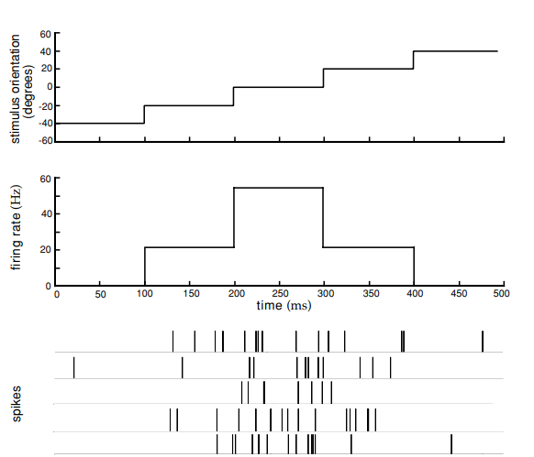
In the image there is an example of a model of an orientation-selective V1 neuron. It is an extremely simplified model of response dynamics because the firing rate at any given time depends only on the value of the stimulus at that instant and not on its recent history. As we can see the orientation angle in the example increases in a sequence of steps and the firing rate follows these changes. In the bottom part of the image we have five different trials of the Poisson process which are an irregular firing pattern that reflects the underlying rate but varies from trial to trial.
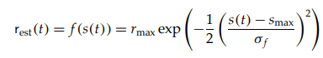

Comparison with data - p.48
- The Poisson process is simple and useful, but does it match data on neural response variability?

- Fano factor: describes relationship between mean spike count $⟨r⟩$over a given interval and the spike-count variance σ_{n}² .
- From a wide variety of neuronal recording we can fit the equation σ_{n}² = A$⟨n⟩$^{B}
  - With A and B typically between 1.0 and 1.5 because Poisson model predicts A = B = 1
    - ⟹ data show a higher degree of variability than the Poisson model would predict. 🙁
    - But those data usually come from anesthetized animals, which have response variability higher than in alert animals. 🙂

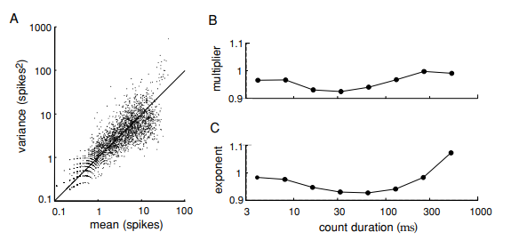

In the image we have data from spike-count means and variances extracted from MT (Medial Temporal) neurons in alert macaque monkeys using a number of different stimuli.
- The MT area contains many neurons which are sensitive to image motion.
- In the left image we have individual means and variances plotted.
- They cluster around the diagonal, aka they follow the Poisson prediction.
- Also the values of A and B are close to 1.
- Poisson models seem a reasonable approximation, but of course many neural responses can not be described by Poisson statistics.

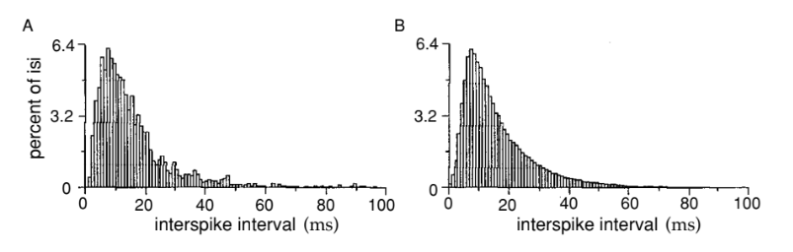
In the left image we have the interspike interval distribution. Count the number of intervals falling in discrete time bins.
- Responses of a non-bursting cell in area MT of a monkey in response to images consisting of randomly moving dots with a variable amount of coherence imposed on their motion.
- Interspike intervals longer than 10 ms ⟹ exponential shape of the histogram, in agreement with 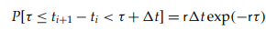
- Interspike intervals shorter than 10 ms ⟹ discrepancy with the formula above, the reason is because of refractoriness making short interspike intervals less likely than the Poisson model would predict.

Data on interspike intervals can be fitted more accurately by a gamma distribution
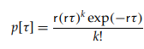
With k > 0 then a Poisson distribution which has k = 0.

On the right image instead we have a theoretical histogram obtained by adding a refractory period of variable duration to the Poisson model. The refractory period was randomly chosen from a Gaussian distribution with mean 5 ms and standard deviation of 2 ms.
⟹ the resulting interspike interval distribution of the right image agree quite well with the data.

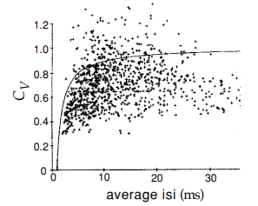

C_{V} values extracted from the spike trains of neurons recorded in monkeys from area MT and primary visual cortex (V1).
- Coefficient of variation is plotted as a function of the mean interval, 1 / $⟨r⟩$
- The solid curve is the prediction of a Poisson model with refractoriness
- Except for short mean interspike intervals the values are near 1, even if they tend to cluster slightly lower than 1.
- For short interspike we have a small C_{V} due to refractory period
The Poisson model with refractoriness provides a good description of a significant amount of data, but there are cases in which the accuracy in the timing and number of spikes fired by a neuron is considerably higher than would be implied by Poisson statistics.
- Another deficit is that the Poisson model does not provide a mechanistic explanation of neuronal response variability.

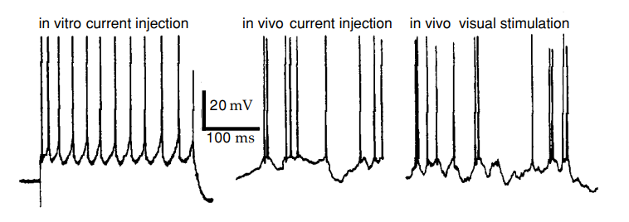
As we can see in this image spike generation by itself is highly reliable in real neurons. In the image we can see a comparison in the response of V1 cells to constant current injection in vivo and in vitro.
- In vitro (left image): the neural response is regular and reproducible spike train.
- In vivo (right image): the neural response is highly irregular in firing (central panel) and is similar to the response to a moving bar stimulus (right panel).

Conclusions:
- Even if the Poisson model for spike generation can capture some statistical properties of firing variability, the spike generating mechanism itself in real neurons is clearly not responsible for the variability.
- Some neurons fire action potential in clusters or bursts of spike that can not be described by the Poisson process with a fixed rate.
  - Even if we can include bursting in the Poisson model by allowing firing rate to fluctuate is still not enough in some cases

1.5 The neural code - p.51
Central issue in neural coding: are the individual action potential and the individual neurons encoded independently of each other or is there some sort of correlation between different spikes and different neurons that carry significant amounts of information?

Two opinions:
- Independent-spike and independent neuron codes.
- Correlation code.

(later we will see the issue of temporal coding: do neurons use rate coding or temporal coding?)

Independent-spike, independent-neuron, and correlation codes - p.51

- Neural response and its relation to the stimulus are completely characterized by the probability distribution of spike times as a function of the stimulus.
  - If spike generation can be described by inhomogeneous Poisson process ⟹ probability distribution can be computed from the time-dependent firing rate r(t) by using 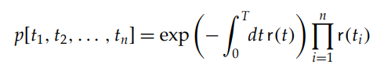

- In reality: information is likely carried both by individual spikes and through correlations. Identifying a correlation code should require that a significant amount of information must be carried by correlations, as much as is carried by the individual spikes.
  - As an example, if we consider spike times individually independently of each other we would miss the information carried by the intervals between them.
  - Information could be carried by more complex relationships between spikes
- Independent-spike codes are much simpler to analyze than correlation codes and most work on neural coding assumes spike independence.
- Was found that information carried by correlation between two or more spikes is rarely larger than 10% of the information carried by spikes considered independently.
  - It is still possible that we have not yet uncovered or examined the types of correlations that are most significant for neural coding:
    - But it is unlikely
    - Evidence for independent-spike coding, at least as a fairly accurate approximation, is quite convincing

Information is typically encoded by neuronal population and not by single neurons. When we study population coding we must consider whether individual neurons act independently or whether correlations between different neurons carry additional information.
- The analysis of population coding is easiest if the response of each neuron is considered statistically independent (as typically assumed). This means that spike trains of different neurons can be combined without taking correlations into account.
- We must ask whether correlations between the spiking of different neurons provide additional information about a stimulus that can not be obtained by considering all of their firing patterns individually.

lecture 4/5 (slide 35) - pag 53 del pdf

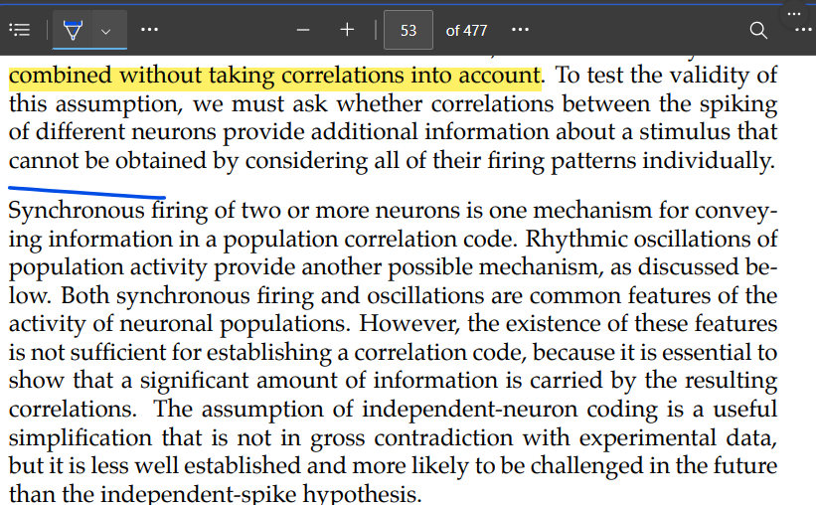
.

NOTE: even if there is a higher concentration of K⁺ inside the neuron than outside the membrane potential can still be negative because it depends on a combination of factors and not only K⁺ concentration.
NOTE: V_{T} = RT/F = k_{B}T/q that’s why the two equations are the same.
Increased conductance means reduced electrical resistance.
NOTE: the channels themselves do not have current, they allow ions to flow through them and this creates a current across the neuron’s membrane.
The electrical property of neurons are critical for their function in transmitting and processing information in the nervous system
In theory an infinite amount of trials

